The concept of the VCE is easy to understand but not so easy to define for each business.

The VCE aims to understand all the stakeholders (including the value chain that directly impacts the business) that influence the creation of value for the end customer (and other possible beneficiaries of the system)

When we talk about the value proposition to the customer, we mean the Value proposition definition you have been defining in your project: Here is an example of what we mean by creating value for the client: https://www.youtube.com/watch?v=ReM1uqmVfP0&feature=youtu.be

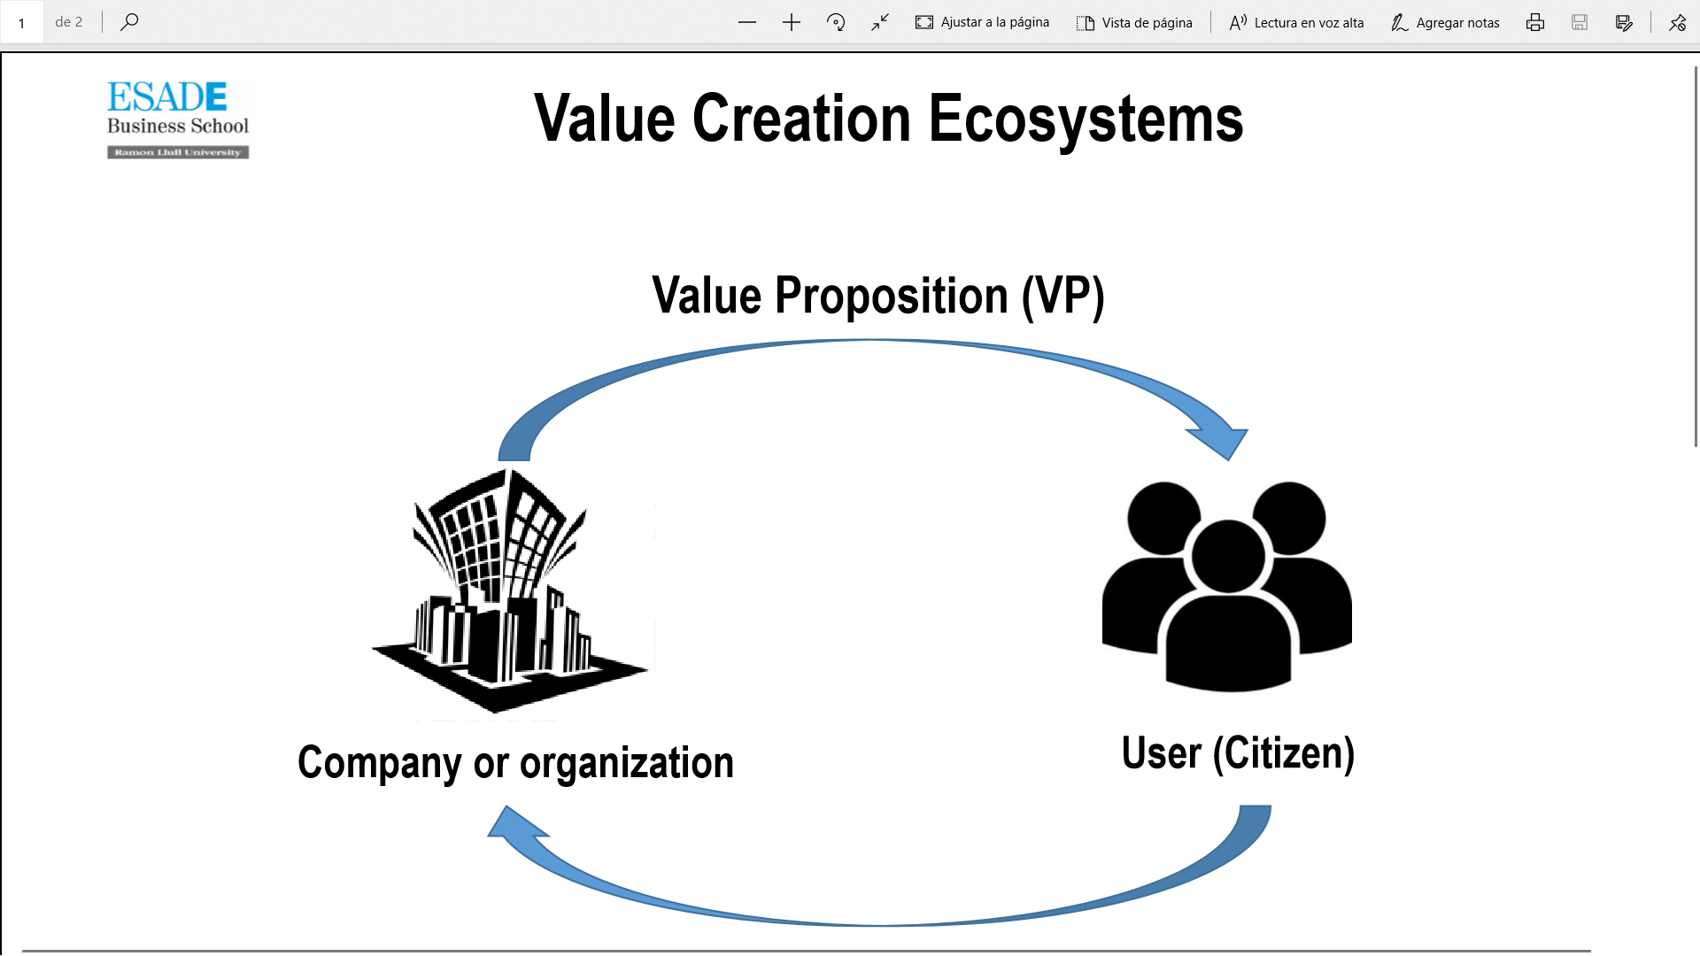

For this, it is important to identify and understand all the stakeholders that participate in this value-creation process

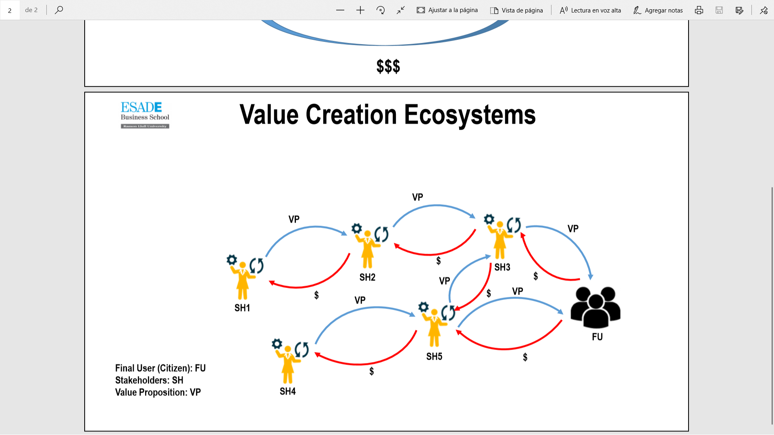

It is important to consider what are the efforts/costs and benefits for each of these stakeholders.

To build the VCE, the first thing to do is identify all the actors that are related to our business and then understand the value contribution of each of them, as well as their costs and investments.

For a business to be sustainable, not only must our business model be sustainable, but also the rest of the value chain that contributes to it,

Here you have a couple of examples of this

How we can improve our value creation by collaborating with another stakeholder in the sector: Value creation ecosystems: <https://www.youtube.com/watch?v=kcpQd7-geuc>

Example in for natural services like pollination or clean water: <https://www.youtube.com/watch?v=4U9nbhzvOYI>

In this case, it is important to understand that profitability objectives are only sometimes present throughout the ecosystem and that their organizational and financing models to obtain minimum sustainability can be very different.